CENG 201 - Hospital Patient Management System Report
Name: Alp Doruk Sengun
Student ID: [230444401]

Task 1: Patient List Analysis
In this first task, I built a PatientList class manually. The homework rules said I cannot use Java's ArrayList or LinkedList. So, I had to write my own Linked List using nodes and pointers. This was good practice to understand how memory works.
Big O Complexity Analysis: I checked my code to find the time complexity:
- addPatient(Patient p): This method is O(n). In my code, I don't use a "tail" pointer. Every time I add a patient, the loop starts from the head and goes to the last node. If I used a tail pointer, it would be O(1), but O(n) is okay here.
- removePatient and findPatient: These are also O(n). The code has to check every node one by one to find the correct ID. In the worst case, the patient is at the end of the list.
Linked List vs. ArrayList: The PDF asked to compare these two. For a hospital system, Linked List is better. If I used an ArrayList, removing a patient is hard. When you delete someone from the start of an ArrayList, the computer must shift all other items to the left. This shifting operation takes O(n) time and uses extra processing power. But in my Linked List, removing is fast and clean. I just change the next pointer of the previous node. I don't need to shift any data. Because patients come and go frequently, the Linked List is much better for managing the memory.

Test Output:

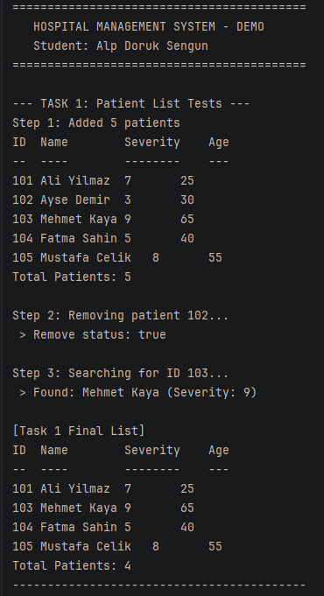

Task 2: Treatment Queue Analysis
For Task 2, I wrote a TreatmentQueue class. I used the Queue data structure because it works on FIFO (First-In-First-Out) logic. This is the only fair way to run a hospital waiting line. The person who comes first must get the treatment first.
Why did I use a Queue? It guarantees fairness. My code uses front and rear pointers.
- Adding a request (enqueue) happens at the rear.
- Removing a request (dequeue) happens at the front. Both operations are O(1) (constant time). This means the system is very fast, even if there are many patients.
Queue vs. Stack (Starvation Problem): The analysis question asked: "What if we used a Stack?" If I used a Stack (LIFO), it would be very bad for the hospital. In a Stack, the last person to enter gets treated first. Think about a patient who arrives at 9:00 AM. Then new people come at 9:05, 9:10, etc. If we use a Stack, the doctor always treats the new people. The patient from 9:00 AM stays at the bottom and never gets treated. In computer science, we call this "starvation." It is totally unfair. That is why a Stack is the wrong choice for a waiting line, and we must use a Queue.

Test Output:

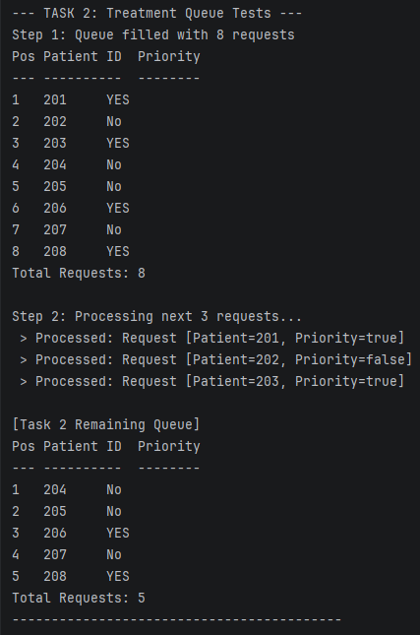

Task 3: Discharge Stack Analysis
For the third task, I made a DischargeStack. This stores the records of patients who finished treatment. I used a Stack data structure here, which follows LIFO (Last-In-First-Out).
Why is a Stack good here? I chose a Stack because discharge records are like a "History Log" or "Undo" feature. Usually, when we look at logs, we want to see the most recent event first. For example, if the admin wants to see who left the hospital 5 minutes ago, the Stack shows that record immediately at the top. In my code, both push (add) and pop (remove) are O(1) operations. I just update the top pointer, so it is very efficient.
Stack vs. Queue: If I used a Queue for the discharges, I would see the oldest record first. This is not a mistake, but it is not very useful.
- Queue: Shows records from Oldest to Newest.
- Stack: Shows records from Newest to Oldest. Since we usually want to check the latest work first, the Stack is the better logical choice. Performance-wise, both Stack and Queue are O(1) in my Linked List implementation, so the speed is the same. The difference is only in the order of data.

Test Output:
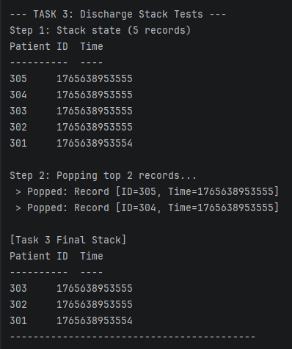

Task 4: Integrated System & Priority Analysis
This was the last and hardest task. I had to put the List, Queue, and Stack together into a HospitalSystem class. I also had to add "Priority" for emergency patients and a sorting algorithm.
How I handled Priority: The problem was finding priority patients without searching the whole list (which is slow O(n)). I solved this by using Two Queues.
- priorityQueue: Only for emergency patients (isPriority = true).
- normalQueue: For regular patients.
When the processTreatment() function runs, it checks the priorityQueue first. If anyone is there, they get treated. If that queue is empty, then it checks the normalQueue. This design ensures emergencies are handled first. Also, it keeps the time complexity at O(1) because I am just looking at the front of two queues.
Sorting Algorithm (Merge Sort): I also added a sorting function to order patients by severity. I picked Merge Sort. I chose Merge Sort because it is stable and always runs in O(n log n) time. I could use Bubble Sort because it is easier to code. But Bubble Sort is O(n^2). If the hospital has 1000 patients, Bubble Sort would be very slow. Merge Sort is much faster for big data.
Heap vs. My Method: The PDF asked about using a Heap (Priority Queue). My "Two-Queue" method is great (O(1)) for simple cases (High vs Normal). But it has a limit. If we had 5 different priority levels (Level 1 to Level 5), I would need 5 queues. That would be messy code. In that case, a Binary Heap is the professional choice. A Heap can handle many priority levels. Adding and removing from a Heap takes O(log n) time. So, my code (O(1)) is technically faster for this homework, but a Heap is more flexible for complex systems.

Task 4: Integrated System & Priority Analysis Test Output:
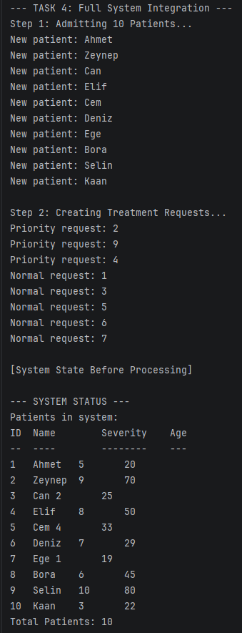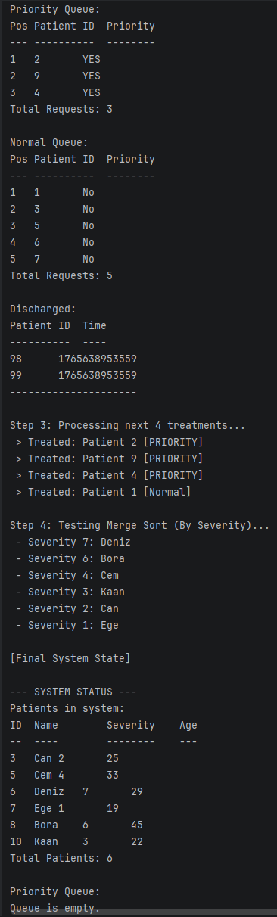
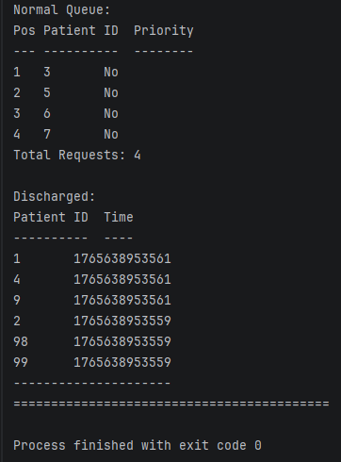

This Project O(n) Summary Table is :
Structure | Operation | Complexity
Linked List | Add, Remove, Find | O(n)
Queue | Enqueue, Dequeue | O(1)
Stack | Push, Pop, Peek | O(1)
Merge Sort | Sort | O(n log n)
Two-Queue Priority | Add, Process | O(1)
Binary Heap | Add, Remove | O(log n)

